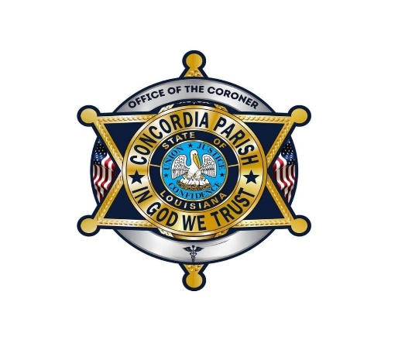
OFFICE OF THE CORONER
Pamela Poole, RN – Coroner
Parish of Concordia ▪ State of Louisiana
P.O. Box 580 ▪ Vidalia, LA 71373

Authority to Cremate

This form must be accompanied by Authority to Cremate signed by proper relative or
legal representative of the deceased and Funeral Director, together with cremation
permit from the Bureau of Vital Statistics.

I, __________________________Coroner, for the Parish of CONCORDIA State of LA, do hereby certify that an autopsy

___was performed OR ___was not performed on the body of

_____________________________________, whose death occurred on
(Decedent’s Name)

the __________________in the city of_______________ State of ______
(Date of Death)

and authorize that said body may be lawfully cremated by____________

funeral home of ___________ in accordance with laws of the state of

Louisiana. The Concordia Parish Coroner’s Office in no way assumes any

responsibility for any wrongful handling and/or disposition of these remains.

Given under my hand this _______day of _________________, 20______.

Signature____________________________________
City Vidalia State LA

